**PCCOER CSE Embedded Workhop by CopperCloud IoT (8-10May 2021)**

**Useful Circuit Assemblies for Projects**

1. **Digital Output –** Controlling digital actuators (LED, Relay, High Current Devices through Relays such as AC light, Door Bell, etc):

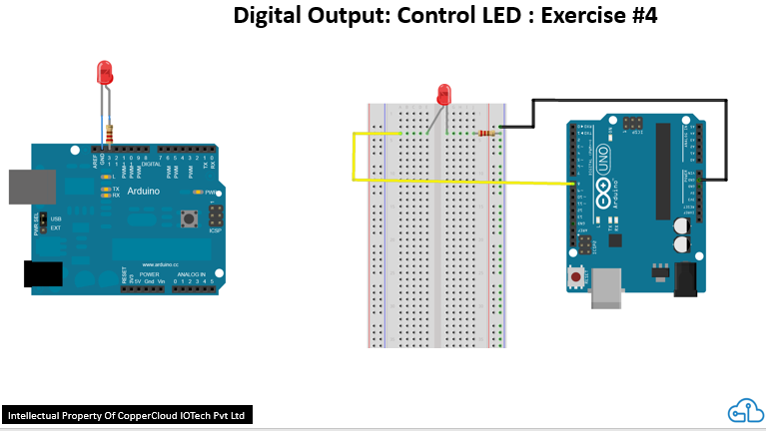

1. **Digital Input –** Reading digital sensors (switch, proximity, IR, motion sensor, bump switch, etc):

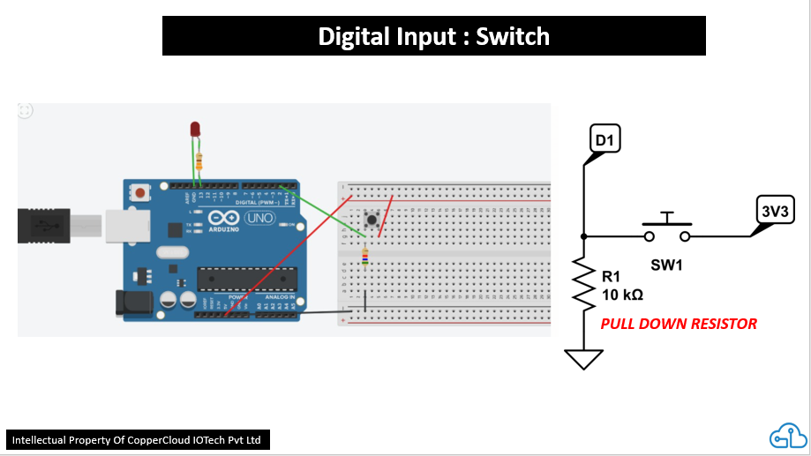

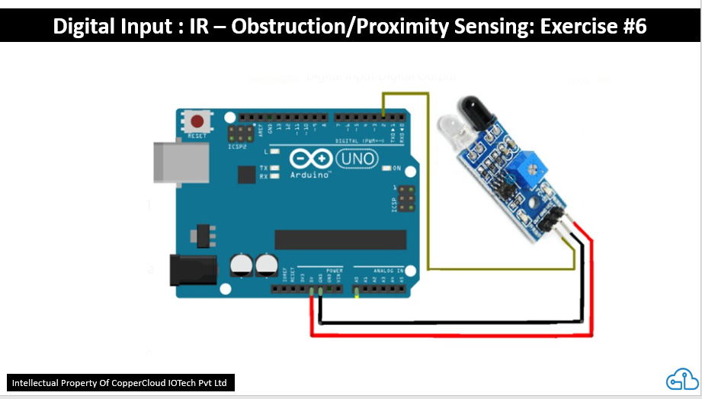

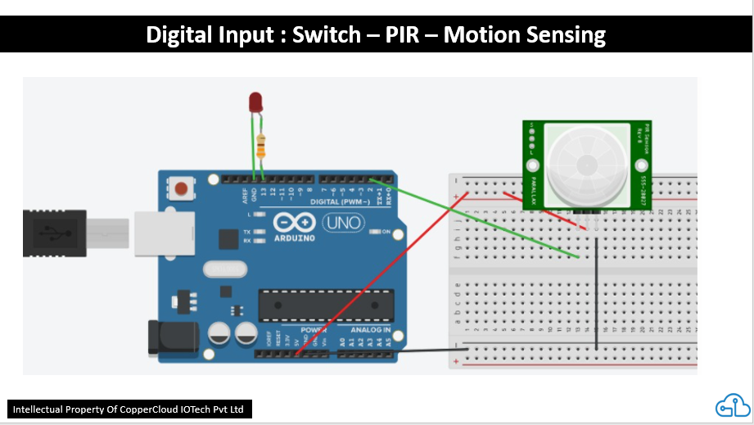

*Continued …*

1. **Ultrasound Sensor –** Measure distance of object in range (could be used for door opening, smart dustbin, etc):

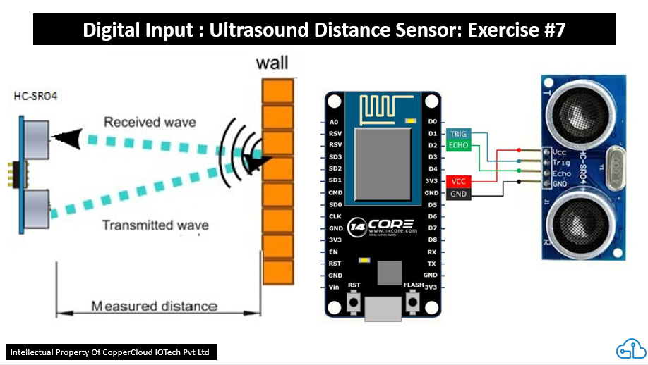

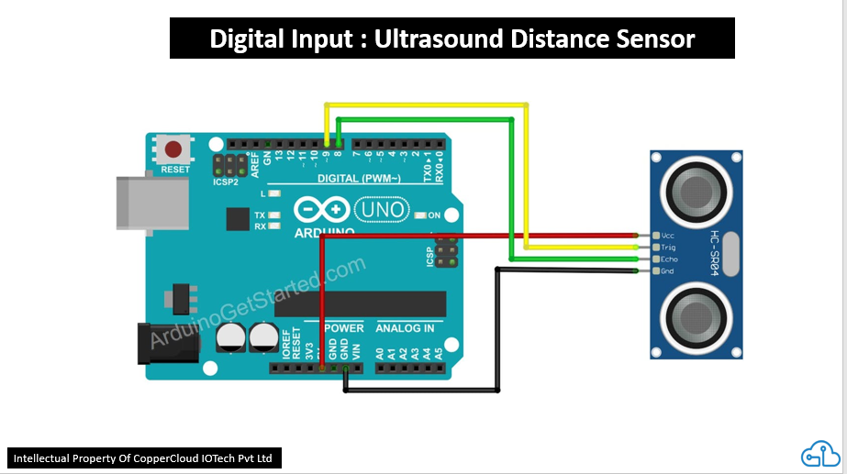

*Continued …*

1. **Reading Analog Sensors –** for temperature sensor, light intensity, air quality, water quality, biomedical sensors, etc:

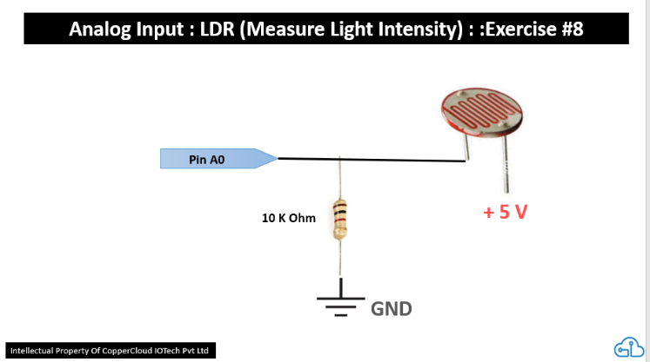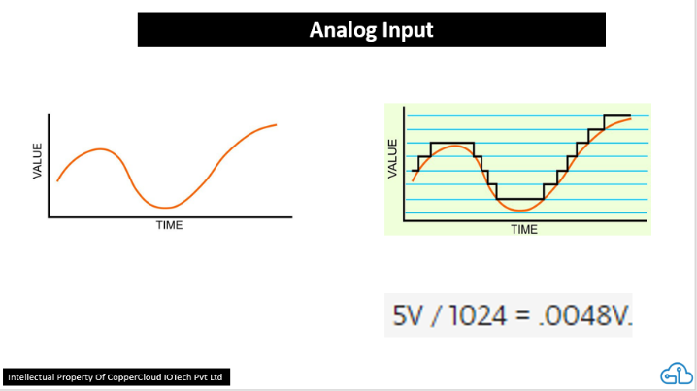

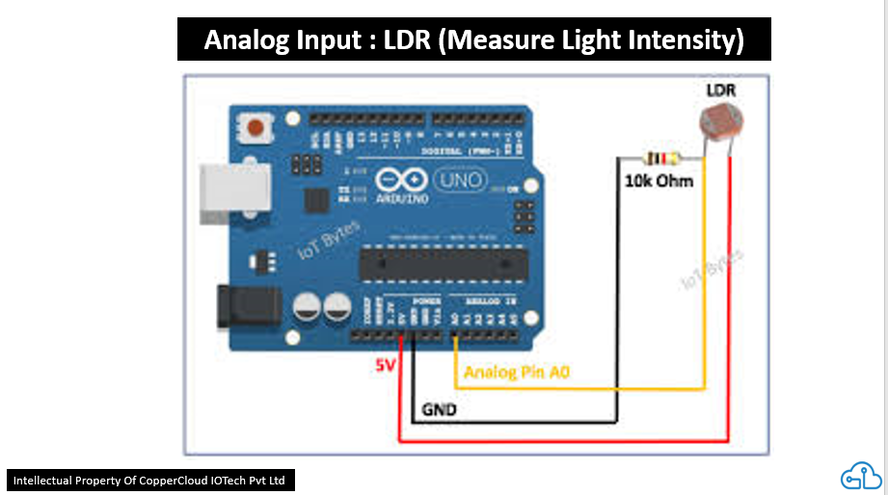

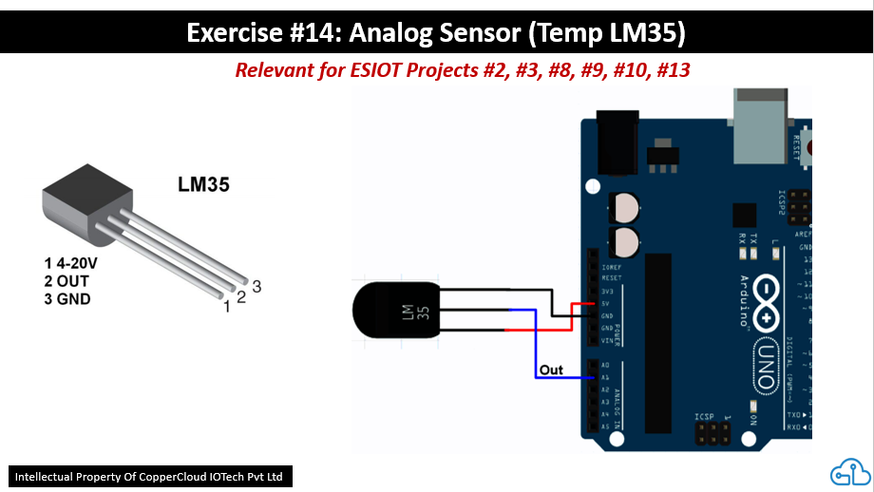

1. **PWM Output (Simulating Analog Output) –** for delivering varying output power for fading leds, varying speed of motors, sirens, servo motors, etc:

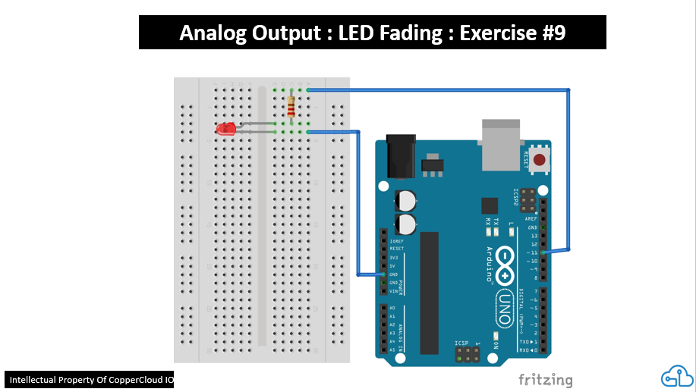

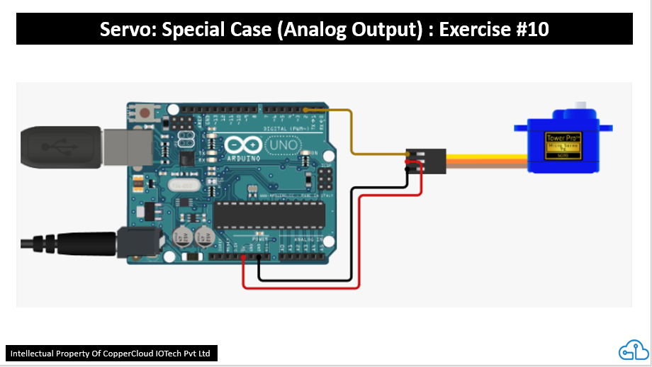

*Continued …*

1. **Relays –** Controlling high current devices (AC lights, DC or AC motors, Solenoids, heating coils, etc):

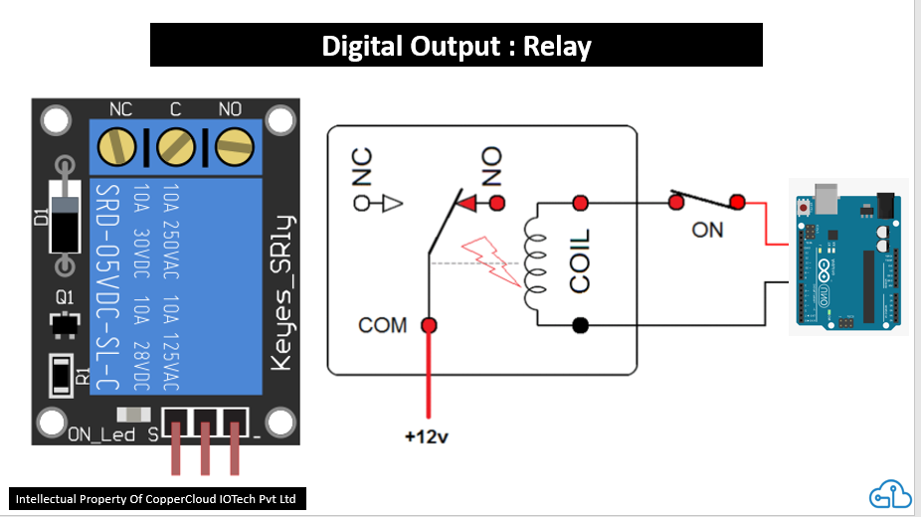

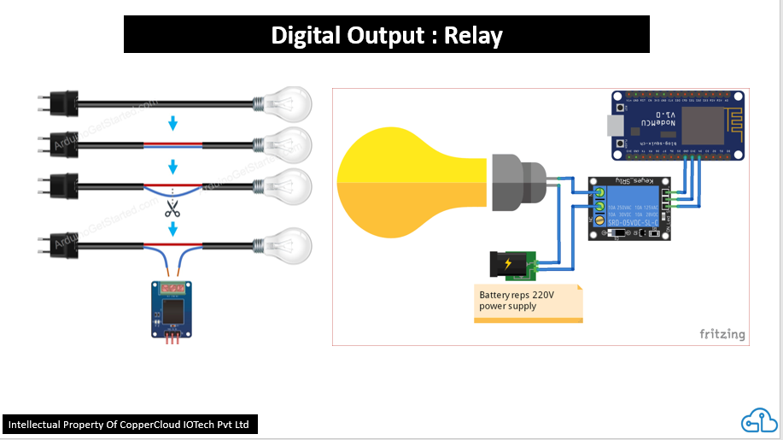

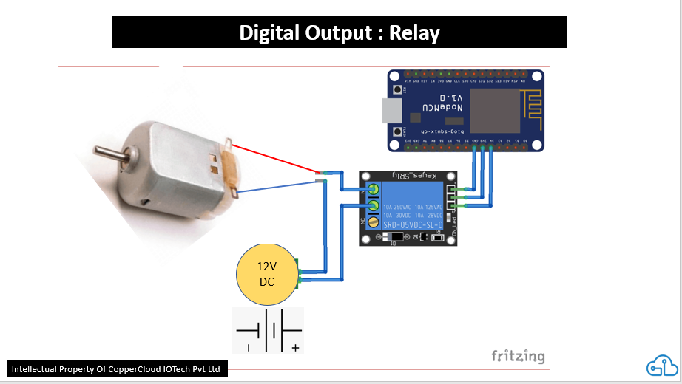

1. **Combining Sensors & Actuators** - to achieve Real-World Solutions:

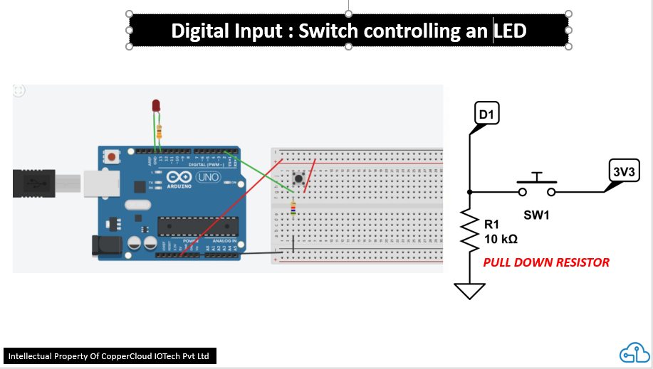

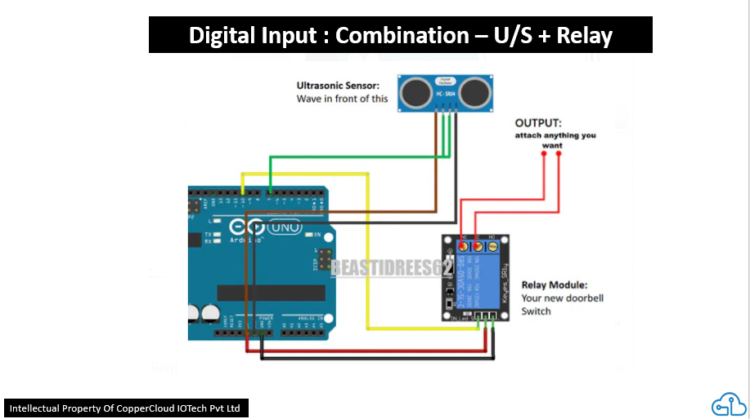

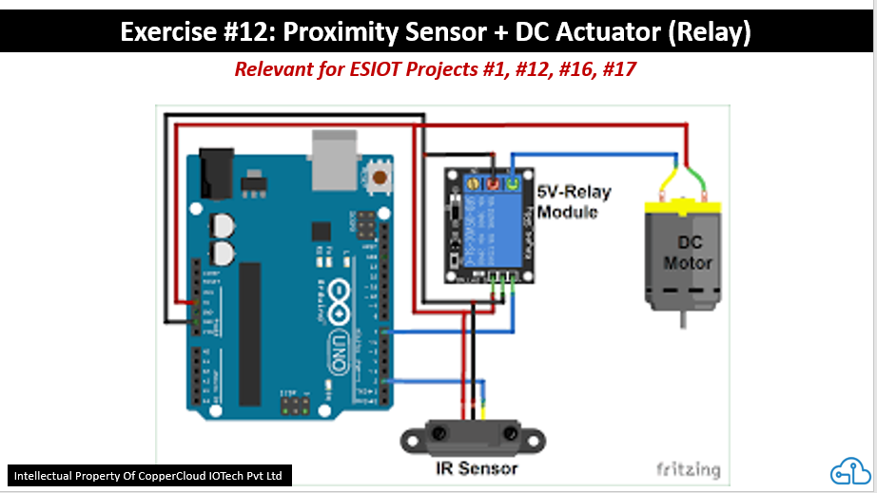

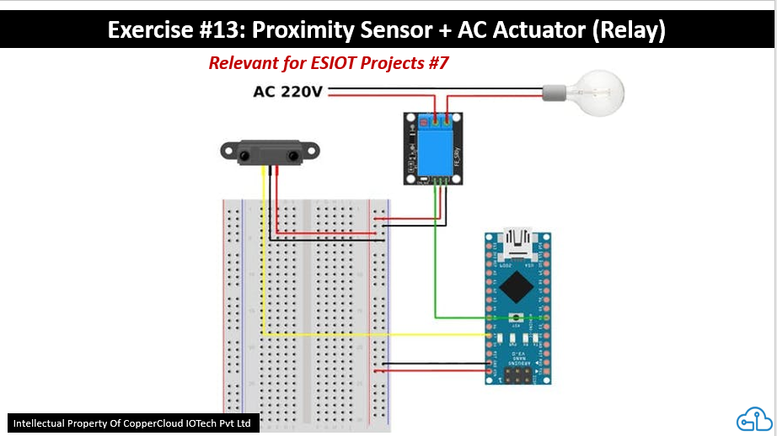

1. **Special sensor integration #1 – RFID Scanner (SPI Interface)**

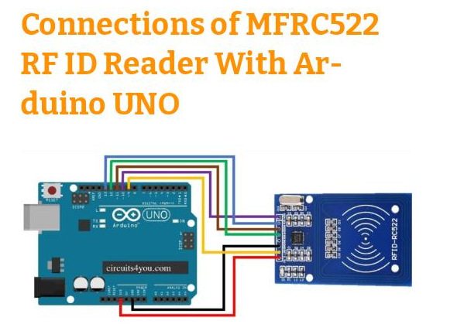

[**https://circuits4you.com/2018/10/03/interfacing-of-rfid-rc522-with-arduino-uno/**](https://circuits4you.com/2018/10/03/interfacing-of-rfid-rc522-with-arduino-uno/)

*Continued …*

1. **Special sensor integration #2 – Contactless Temperature Sensor**

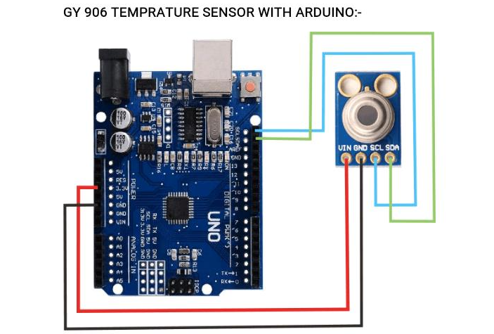

[**https://www.nn-digital.com/en/blog/2019/11/09/interfacing-gy-906-mlx90614-non-contact-ir-infra-red-temperature-sensor-with-arduino/**](https://www.nn-digital.com/en/blog/2019/11/09/interfacing-gy-906-mlx90614-non-contact-ir-infra-red-temperature-sensor-with-arduino/)